Impacts of Excessive Nutrient Loads
in the Mississippi River

By
Student

Master’s Report

ABSTRACT
This paper discusses the current and future impacts on the Gulf of Mexico. There are several factors that contribute to the hypoxia that is spreading across the Gulf, having a dire effect on the habitat and wildlife that reside in the lower depths of the ocean. In the articles, models are being implemented to determine if reversing the deoxygenation is possible for restoration. Changes from humans as well that utilize the Mississippi River for agricultural purposes have to make changes to lessen the amount of excessive nutrients being deposited into the river.
Keywords: Mississippi river, hypoxia, nutrients

Table of Contents
Introduction 5
Definition and causes of hypoxia 5
History 6
Eutrophication-Driven Deoxygenation 6
Impacts of the nutrient loads 8
Ocean Acidification 8
Phytoplankton growth 9
Effects on Fish and Fisheries 10
Climate Change 12
Ecosystem Status 13
Changes in human impact 13
Reducing hypoxia in the Gulf of Mexico 14
Conclusion 16
Works Cited 17

Impacts of Excessive Nutrient Loads
in the Mississippi River

Introduction
The Mississippi River originates from Lake Itasca in Minnesota, flowing south through thirty-one states into the Gulf of Mexico. The River flows for 2,350 miles, making it the second longest river compared to the Missouri River (Mississippi River Facts, 2017). Today the river is an essential source of water to communities and farmers for agriculture. As it flows, many nutrients from runoff and erosion are carried downstream into the Gulf creating the hypoxic zone (See Appendix A for a photo of the hypoxic zone). Several studies are being performed to reduce the nutrients, size, and to restore the habitat for the affected aquatic life. With further research on hypoxia in the Gulf, one day it can be applied to unhealthier areas and hopefully lessen the damage caused by human activity.

Definition and causes of hypoxia
When bodies of water like wetlands and oceans have a low oxygen concentration of less than 2ppm, it becomes hypoxic (About Hypoxia, 2018). Fertilizers, decomposing vegetation, and sewage are some factors that contribute to the Dead Zone. These factors produce phosphorus, nitrogen, and sometimes sulfur that can be difficult to remove. As they flow downstream, the concentration becomes greater before emptying into the Mississippi River Basin. Ecosystems are disrupted and eventually die if the issue persists.
This creates the perfect environment for algal bloom to form on the surface on the water. They absorb oxygen from the water while receiving sunlight from above. Algal blooms eventually die and decompose, absorbing the little oxygen that may be left and killing the few aquatic species can survive in low oxygen environments, making it completely uninhabitable. Stratification is another factor plaquing the Gulf of Mexico (Hypoxia 101, 2017) .The temperature of the freshwater flowing from the Mississippi River is warmer than the saltwater in the Gulf of Mexico. When they meet two layers are formed like oil-in-water, preventing the freshwater from mixing with the dense, saltwater. Oxygen levels in the Gulf are low and with the freshwater remaining on top fish are able to avoid the area, but small species like crab and shrimp die due to lack of oxygen.

History
Signs of hypoxia first appeared in the Gulf of Mexico in 1972, but consistent documentation began in 1987 to track the movement and spread of the nutrients loads. Over the past 25 years information, studies, and teams have come together to lessen the impact on the ecosystem. One organization in particular, Mississippi River/Gulf of Mexico Watershed Nutrient Task Force, was developed in Fall 1997 to alleviate nutrient pollution; reduce the size of the zone; restore habitats; and understand the cause effects of eutrophication (Hypoxia 101, 2017). They created the 2001 Action Plan to develop research on the hypoxia in the Gulf, and 5-years thereafter a new assessment is written to track the progress of reducing the loads.

Eutrophication-Driven Deoxygenation
In the last ten years, open ocean researchers have put many efforts in the study of deoxygenation. Their research has revealed that there are some zones in the oceans which have no oxygen while others have low dissolved oxygen. The ancient human activities back in the nineteenth century have led to the emergence of regions of low dissolved oxygen. The changes in oxygen are essential in the enhancement of the ecosystem. In the coastal areas, deoxygenation leads to alteration of sediments. The condition of low dissolved oxygen has gained more significant among researchers since it has adverse negative effects in the ecosystem. In the coastal ocean, deoxygenation leads to conditions of low dissolved oxygen or no oxygen which have an undesired impact on aquatic and aerobic organisms. These conditions lead to mortality, reduced growth, loss of secondary reproduction, reduced biodiversity, and death of fisheries. In 1970, there were several sites of hypoxia in North America. Coastal hypoxia became more prevalent in this region as well of in Japan and Europe in the 1990s. In South America, Australia and Europe cases of hypoxia were reported in the 2000s.
Eutrophication is the increase in carbon accumulation and primary production rate. This condition leased to decrease in hypoxia in coastal waters and consequently leading to consumption of microbial oxygen. There is a close relationship between the global distribution and development of regions of low dissolved oxygen and the development of watershed. There is also an association between the coupling of phosphorus and nitrogen and the production of carbon. For instance, closely related to the Mississippi river’s hypoxic zone is nitrate loads.
The dynamics of oxygen have close integration with the chemistry of silica, phosphorus, carbon, nitrogen, sulfide and trace metals in sediments and in water. The composition of chemically related to decreasing in hypoxia depends on the amount of time that oxygen has been exposed. On a seasonal basis, highly productive surface waters lead to over 100% saturation levels of oxygen. Deoxygenation has no impact on the organic carbon that is contained in sediments and surface waters though they are the leading causes of reducing concentrations of oxygen.
The presence of long-lasting severe hypoxic events has led to a decrease or shift in benthic organisms. There is a suit of sediments that is harbored in the residues and can be seen as indicators of chemical or biological alterations in the water column — the high content of organic carbon results from anoxic conditions where there is immense preservation of organic matter. Early Holocene is characterized by high organic carbons contained in laminated sediments. The increase in surface water nutrients in Mississippi River plume led to an increase in biogenic silica accumulation. Atchafalaya River and Mississippi River have influenced the accumulation of sediments which show an increase in the percentages of silica, carbon, and nitrogen.
Human activities have contributed to changes in the world's climate. It is said that these changes will remain constant even if greenhouse gases are kept under control. This is because there are lagging effects that may have implications for centuries to come. The leading causes of these changes include shifts in patterns of wind, altered hydrological cycles, and increased temperatures. High temperature may lead to increased density of coastal and estuarine water and lowered water salinity. Regional winds patterns may also be influenced by high temperature which changes the mixing and circulation of the wind. It is now confident that there will be a continued increase in the global reports of hypoxia while the quality of coastal waters will be decreasing in the number of nutrient loads due to changes in climate.

Impacts of the nutrient loads

Ocean Acidification
With nutrient pollution affecting the ecosystem water, quality in the Gulf of Mexico will continue to decrease over time. Acidification will intensify in the future if hypoxic levels rise with no conservation efforts being implemented. Anthropogenic carbon dioxide are gasses emitted into the air due to human activity. When the CO₂ fails to be recycled back into the atmosphere, acidification on metazoans causes at least three biological effects: (1) direct effects of altered carbonate chemistry on external shell dissolution in calcifiers, (2) pathological effects of an altered acid–base status on biomineralization and physiological processes and (3) impacts of an altered acid–base status on species’ energy budgets (Melzner, Thomsen, Koeve, & al, 2012). Shells and exoskeletons on invertebrates become thin while exposed to the acidic water. Some of their physiological process of respiration becomes altered while hypercalcification causes behavioral disturbances. Metabolism in the metazoans decrease, and energy reserves are used to maintain homeostasis. Future calculations show that acidification will not be possible for the next 100 years based on the current CO₂ values. Upcoming research on hypoxic coastal areas should focus more on upwelling events, seasonal changes, temperature, and species responses in relation to O₂.

Phytoplankton growth
Phytoplankton are a type of algae that requires sunlight and nutrients to grow. Although small, they are a source of food as well for many sea creatures like jellyfish, whales, and shrimp. They were used in this study to see if nitrogen (N), phosphorus (P), or a combination of both would place growth limiters on the population. Both N and P are essential nutrients to phytoplankton growth, but management of the amount they receive will control overgrowth. 158 bioassays were collected over 8 months, excluding the winter months (Turner & Rabalais, 2013). The phytoplankton were placed in 10mL test tubes and given concentrations of inorganic N, inorganic P or both, and were extended 2 to 3 days past the peak biomass accumulation to a total of 5 to 10 days. The salinity range was higher, between 0 and 36, compared to past experiments with a salinity between 17 and 29. The results showed that light limitation occurred where salinity was <20. Phytoplankton growth becomes mostly N- or NP-limited where salinity is >20, and (3) an N and P synergism exists most strongly where salinity is >30 (Turner & Rabalais, 2013). Therefore, reducing the loads in the will decrease eutrophic waters and lessen the potential of hypoxia.

Effects on Fish and Fisheries
There has been commendable publication of the formation of the extensive zone of low dissolved oxygen on the coast of Louisiana. It has been proven to be difficult to establish the impact if the establishment of this zone of hypoxia on fisheries and fish. The negative impact of low levels of dissolved oxygen and the positive consequences of bottom-up fueling commonly referred to as the nutrient loading dual effects significant in the quantification of the impact of hypoxia in fisheries and fishes. The determination of the net impact of these zones on fish and fisheries as well as a focused effort in the separation of the positive and negative impacts has become a subject of focus by the researcher. The study used a model of the ecosystem that assumes a holistic focus by simulating the interaction of species while keeping a check on the spatial distribution adjustments as well as the changes in biomass.
The primary increase in production in the coastal area of the Gulf of Mexico is associated with the nutrient-rich water that is brought by the waters of the Mississippi River. When the nutrients in the water decompose, followed by the summer stratification leads to conditions of hypoxia. This phenomenon started in the early years of the 1970s. These ‘dead zone' lead to reduced growth and feeding rates., avoidance behavior, alterations in activity levels and mortality of shellfish and fish. Predator-prey relationships are some of the indirect impacts of low levels of dissolved oxygen. For instance, fish may be affected by the behavior of the organisms that they feed on due to the effects of hypoxia. The impact of the change in changes in the prey on fish may be positive or negative. The effect of such alterations on the prey on fisheries may be a bit complicated as the catch results in my either increase or decrease. On the one hand, hypoxia may increase the concentration of prey hence making it easier to catch more while still, it may kill the pray making the concentration of fish low in the coastal area.
The efforts of nutrient reduction in the coastal areas of the Gulf of Mexico cannot be achieved without incorporating the nutrient enrichment effects on phytoplankton in an inclusive model that focuses on the effects of zones of low dissolved oxygen and suggestions that may reduce such impacts.
The results of the study indicated that hypoxia might favor the landing of some fisheries such as the squid and the crab. The crab landing is directly affected by the effects of the zones of low dissolved oxygen while the arrival of squid is due to indirect influence. There are some species which experience higher positive effects in the presence of nutrient-enriched water while they are not mostly affected by hypoxia such as the Atlantic croaker. It was also proven that there is no single model of nutrient removal can remove all nutrients from the waters of the Gulf of Mexico. The red snapper was proven to be affected by both conditions of high nutrients as well as hypoxia. Additionally, jellyfish showed a positive increase in biomass in the presence of hypoxia, and hence it uses such zones as the hiding place from predators. The study concluded that hypoxia does not necessarily have negative effects on overall fisheries biomass or landing, but it has some positive impact on some species.

Climate Change
There have been many stressors, from climate change to oil spills, that have a huge impact on the ecosystem. Climate change is one big influence on an aquatic species’ physiological processes, like reproduction and feeding patterns. It is apparent that hypoxic zones are intensified in the warmer months, therefore, future prediction of temperature increases will give an idea on how to better manage the zones. Oxygen solubility continues to decrease during the summer months, while stratification is enhanced by the surface water heating, preventing the surface water to mix with the underlying seawater. Aquatic species like crab and fish have an increased demand for metabolic oxygen in order to maintain a tolerance in the environment, but the demand to keep becomes impossible when algal blooms continue to grow and deplete the remaining oxygen.
Significant evidence shows that the climate change is occurring, and rising temperatures extend the duration of the dead zones. Several factor contribute to the noxious environment; Rising sea levels, prolonged summer seasons, and precipitation intensity. With the climate steadily rising, it is predicted that the temperature of the dead zones will increase by 2°C by the end of the century (Altieri & Gedan, 2014). As the understanding of the climate change affects becomes refined, models can be developed to better manage the dead zones and possibly decrease the anthropogenic impacts on ecosystem.

Ecosystem Status
The Gulf of Mexico is one of the United States biggest economical producers with fishery and tourism bringing most of the revenue. But with the Gulf becoming hypoxic, there has been a decrease in the number of aquatic species and their habitat. This is due anthropogenic impacts and increasing population growth in the Gulf over the past 50 years (Karnauskas, Scjirripa, Kelble, Cool, & Craig, 2013). Human health can be impacted as well for those who are dependent on the ecosystem. Potential indicators should be put in place to evaluate the status of the ecosystem while slowing down any possible damage.

Changes in human impact
Nitrogen and phosphorus are some of the main pollutants that flow into the Gulf of Mexico, contributing to the hypoxia plaguing the ecosystem. The purpose of the study was to evaluate two ways to apply conservation policies on agricultural land use. The USDA Conservation Effects Assessment Project (CEAP) was developed to evaluate nutrient pollution and how it is being delivered to the Gulf of Mexico. Most of the pollutants being deposited into the river come from cultivated croplands producing corn and soybean crops. Two models were used, Agricultural Policy/Environmental eXtender (APEX) and Soil and Water Assessment Tool (SWAT), to simulate flow, sediment, and nutrients deposition (White, Santhi, Arnold, & al, 2014). APEX models small watersheds or fields while SWAT was used to model large basins, but parameterization is limited.
The results from this study proved that conservation models put in place by the CEAP on agricultural croplands reduced nutrient loads in the Gulf by 20% compared to no conversation practices. Simulation results showed that cultivated lands are a major source of pollution in the Gulf. Upper Mississippi, Ohio, and Lower Mississippi river regions were the top contributors of pollution, with 87% of Nitrogen and 90% of Phosphorus predicted to reach the Gulf (White, Santhi, Arnold, & al, 2014). This evidence expresses the importance of cropland conservation to provide better water quality.

Reducing hypoxia in the Gulf of Mexico
At the end of 1972, The Clean Water Act was signed by Nixon into law which made the availability of clean water a fundamental human right. The idea was to make the water of the nation swimmable and fishable at the same time. It is one of the essential environmental law to have ever been passed. Prior to this law, waste from all processing plants and households was channeled into rivers making two-thirds of the United States waters unsafe for fishing and swimming. Water pollution by agricultural activities is evident at the entry of Mississippi into the Gulf of Mexico. This gulf has the largest zone of low dissolved oxygen in Mexico and the United States of America. It comes second in the world ranking.
Increased rates of pollution have been contributed by the change in land use form perennials to the farming of row crops. For a long time and before the 1990s, there was a prairie grass cover which emerged after glaciations. It covered more than 69 million ha of the land of the United States of America. Then the water was clean and solid was highly fertile. Increase in demand for food after the World war I led to the emergence of mechanized farming which cleared the grass cover and replaced it with annual crops. The use of fertilizer in the cornfields became the starting point for water pollution. It increased the concentrations of nitrate and nitrous oxide in the surface water which got transported by the Mississippi River to the Gulf of Mexico. More recently, increased demand for corn has increased the number of cornfields in more than five states.
The loss of grass cover was a big mistake for the nation, and it should be revisited. They played a significant role in the conservation of water and promotion of organic matter in the soil. They also served to reduce soil erosion, retention of carbon dioxide from the atmosphere and they trapped nutrients too. The leading cause of hypoxia has been revealed to be nutrients associated with the production of row crops. The most substantial proportion of nitrogen in the gulf comes from agricultural activities.
There have been efforts to reduce levels of low dissolved oxygen in the Gulf of Mexico. A group of activist citizens once went to court to force the (USEPA) to make efforts to eradicate the Gulf's hypoxia. The Hypoxia Task Force formed in the year 1970 conducted a study to reveal the leading causes of hypoxia and came up with ways of minimizing its effects. USEPA also made efforts to reduce P and N loadings in the waters of the nation when it commissioned its regional officers to critical steps in the fight. There was a reduction of the amount of N delivered at the Gulf between the year 1997 and 2007, but since then there has been a significant increase.
Significant investments have been made in research related to perennial-based bioenergy. There are three related research centers in the United States of American for the conduction of the proposed research. They should come up with suggests for biofuel systems that produce bio-oil from perennial grass. They should also come up with models of that link land use with the loading of N into the Gulf of Mexico. Additionally, they should even come up with water and soil assessment models. Finally, they should come up with recommendations on how to return perennial grass into the agricultural system.

Conclusion
Hypoxia will remain an issue if excess nutrient loads continue to flow in the Gulf of Mexico. Management practices must be enforced along the Mississippi River in agricultural croplands to decrease the impact on the ecosystem. There are already early signs of the habitats disappearing, which also has an economic impact on the fisheries that depend on the native fish and shrimp to survive. Creating alternative methods to decrease nutrient will take time but will be beneficial in preventing the spread of the hypoxic zone.

Works Cited
About Hypoxia. (2018). Retrieved May 25, 2018, from Gulf of Mexico Hyoxia: https://gulfhypoxia.net/about-hypoxia/
Altieri, A. H., & Gedan, K. B. (2014, August 28). Climate change and dead zones. Retrieved May 27, 2018, from Global change Biology: https://pdfs.semanticscholar.org/9d69/a92311d39fec12fd034e8294fd29e15412d2.pdf
Hypoxia 101. (2017, April 6). Retrieved May 26, 2018, from United States Environmental Protection Agency: https://www.epa.gov/ms-htf/hypoxia-101
Karnauskas, M., Scjirripa, M. J., Kelble, C. R., Cool, G. S., & Craig, J. K. (2013, December). ECOSYSTEM STATUS REPORT FOR THE GULF OF MEXICO. Retrieved May 29, 2018, from Department Of Commerce: https://www.integratedecosystemassessment.noaa.gov/Assets/iea/gulf/GoM_EcoStatusReport_NMFS-SEFSC-653.pdf
Melzner, F., Thomsen, J. ̈., Koeve, W., & al, e. (2012, May 29). Future ocean acidification will be amplified by hypoxia in coastal habitats. Retrieved May 27, 2018, from https://imedea.uib-csic.es/master/cambioglobal/Modulo_III_cod101608/Tema_8-acidificaciÃ³n/hypoxia%20%26%20OA%20Melzner.pdf
Mississippi River Facts. (2017, November 41). Retrieved May 24, 2018, from National Park Service: https://www.nps.gov/miss/riverfacts.htm
Turner, R. E., & Rabalais, N. N. (2013, March 1). Nitrogen and phosphorus phytoplankton growth limitation in the northern Gulf of Mexico. Retrieved May 28, 2018, from Aquatic Microbial Ecology: https://www.int-res.com/articles/ame_oa/a068p159.pdf
White, M., Santhi, C., Arnold, D., & al, e. (2014, February). Nutrient delivery from the Mississippi River to the Gulf of Mexico and effects of cropland conservation. Retrieved May 26, 2018, from https://pdfs.semanticscholar.org/9501/af76fa8aa02515a26937a997ce7ab3e37073.pdf

Appendices

Appendix A
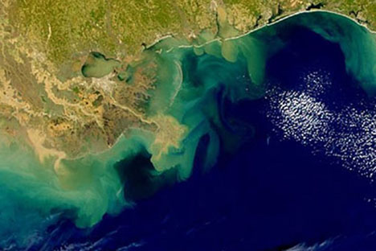
Appendix A: A picture of the hypoxic zone in the Gulf of Mexico
http://earthsky.org/earth/2011-gulf-of-mexico-dead-zone-smaller-than-scientists-predicted

Appendix B
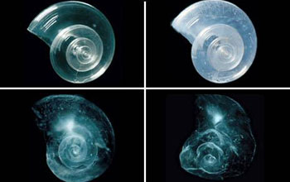

Image of a shell dissolving over a 45-day period in acidic seawater. https://www.nsf.gov/news/news_summ.jsp?cntn_id=125523

Appendix C
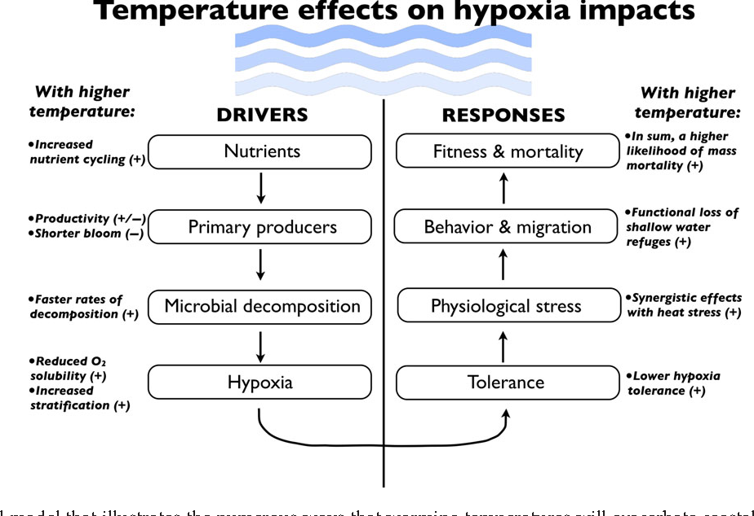

This illustration shows how temperature, along with other factors, have a direct correlation to the way a dead zone responds. https://pdfs.semanticscholar.org/9d69/a92311d39fec12fd034e8294fd29e15412d2.pdf

Appendix D

